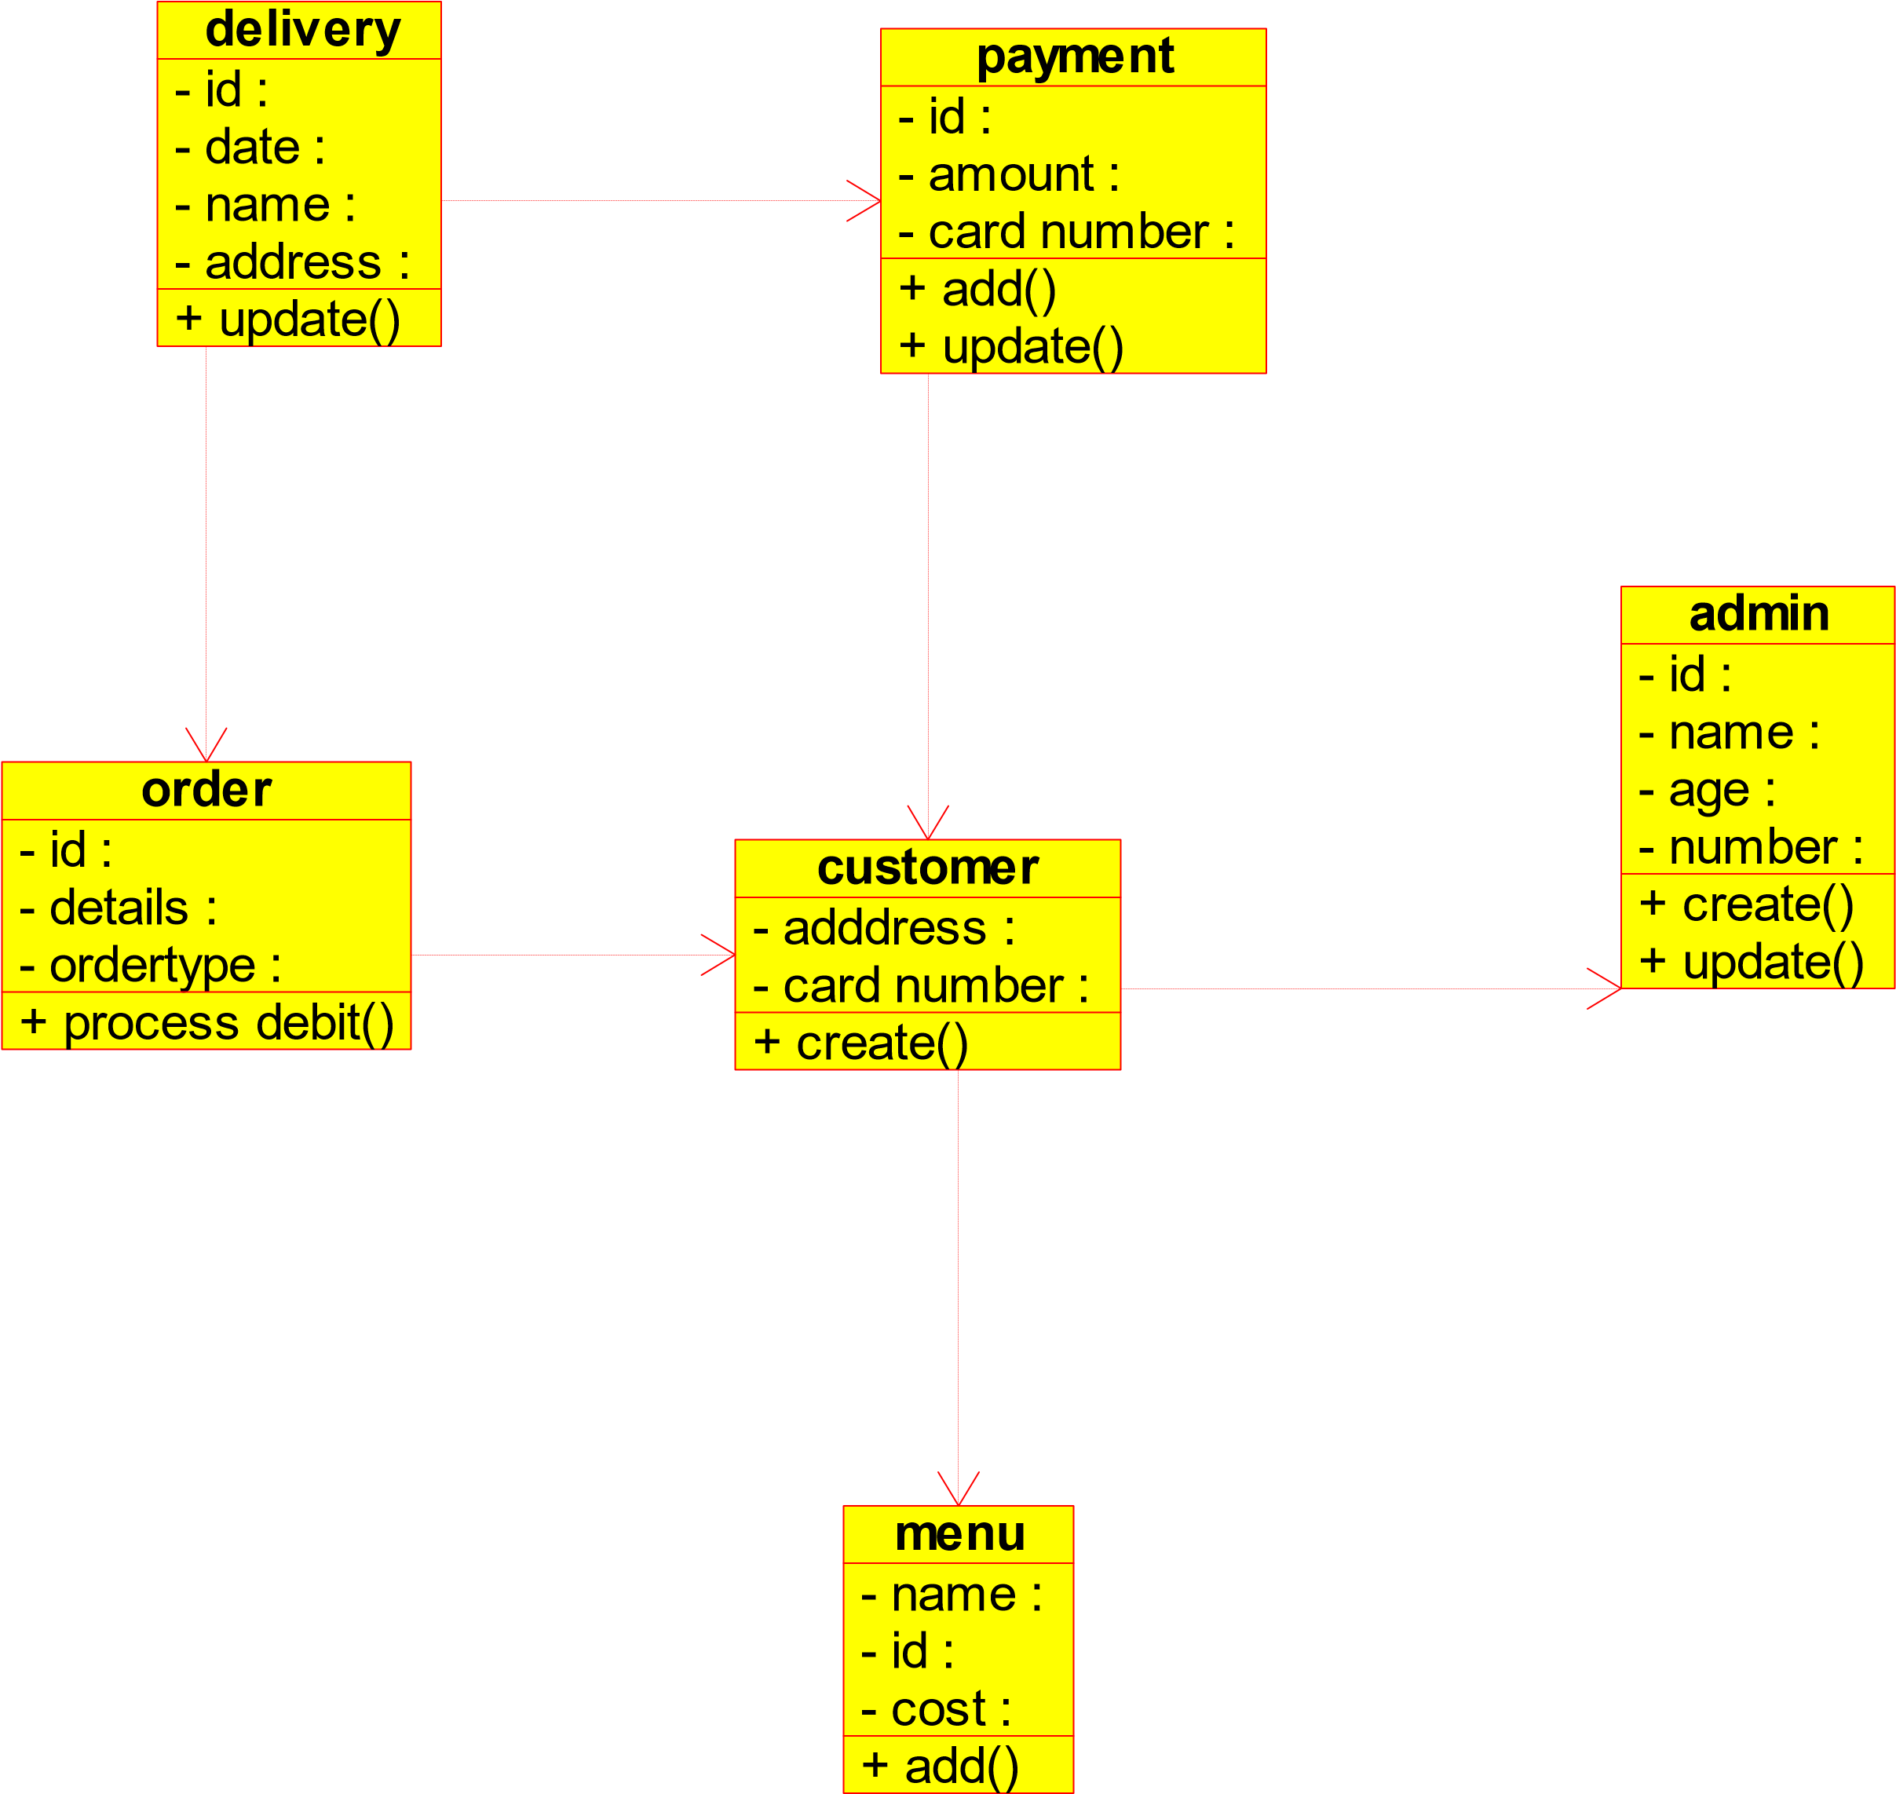

Diagram: class diagram Page 1

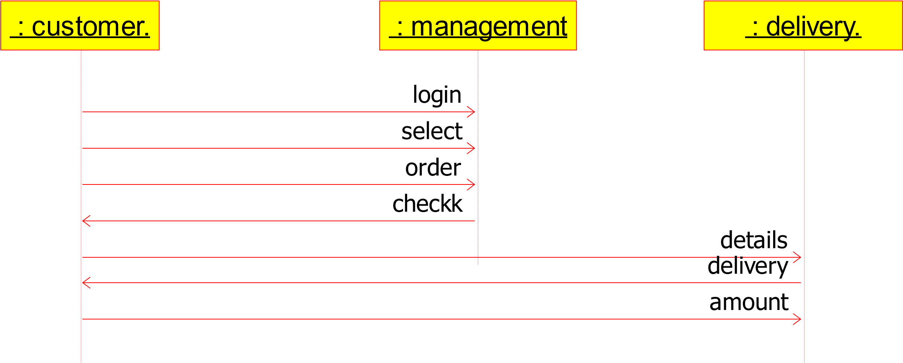

Diagram: sequence diagram Page 1

: Customer

: management.

: delivery boy

1

.search

m2

6

.payment

5

.delivery

3

.order

4

.details recheck

.2

.select

Diagram: colloboration diagram Page 1

login

order

deliver

pay

search

Diagram: state diagram Page 1

login

search

select

details

order

not order

pay

deliver

undeliver

incrt

correct

Diagram: activity diagram Page 1

customer

management

login

check

select

pay

logout

order

deliver

Diagram: use case diagram Page 1

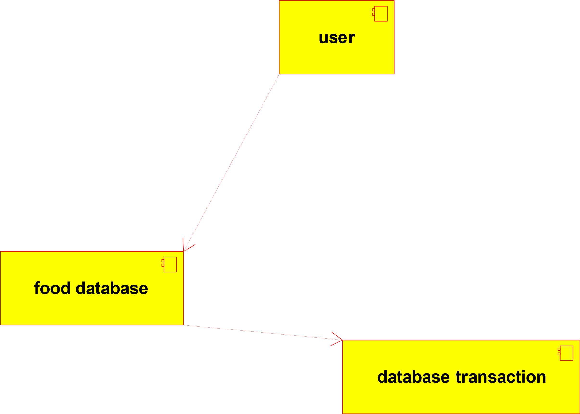

Diagram: component diagram Page 1

web server

client server

database server

# coding=System

from payment import *

from order import *

from customer import *

class delivery(object):

"""

:version:

:author:

"""

""" ATTRIBUTES

_id (private)

_date (private)

_name (private)

_address (private)

"""

def _update(self):

"""

@return :

@author

"""

pass

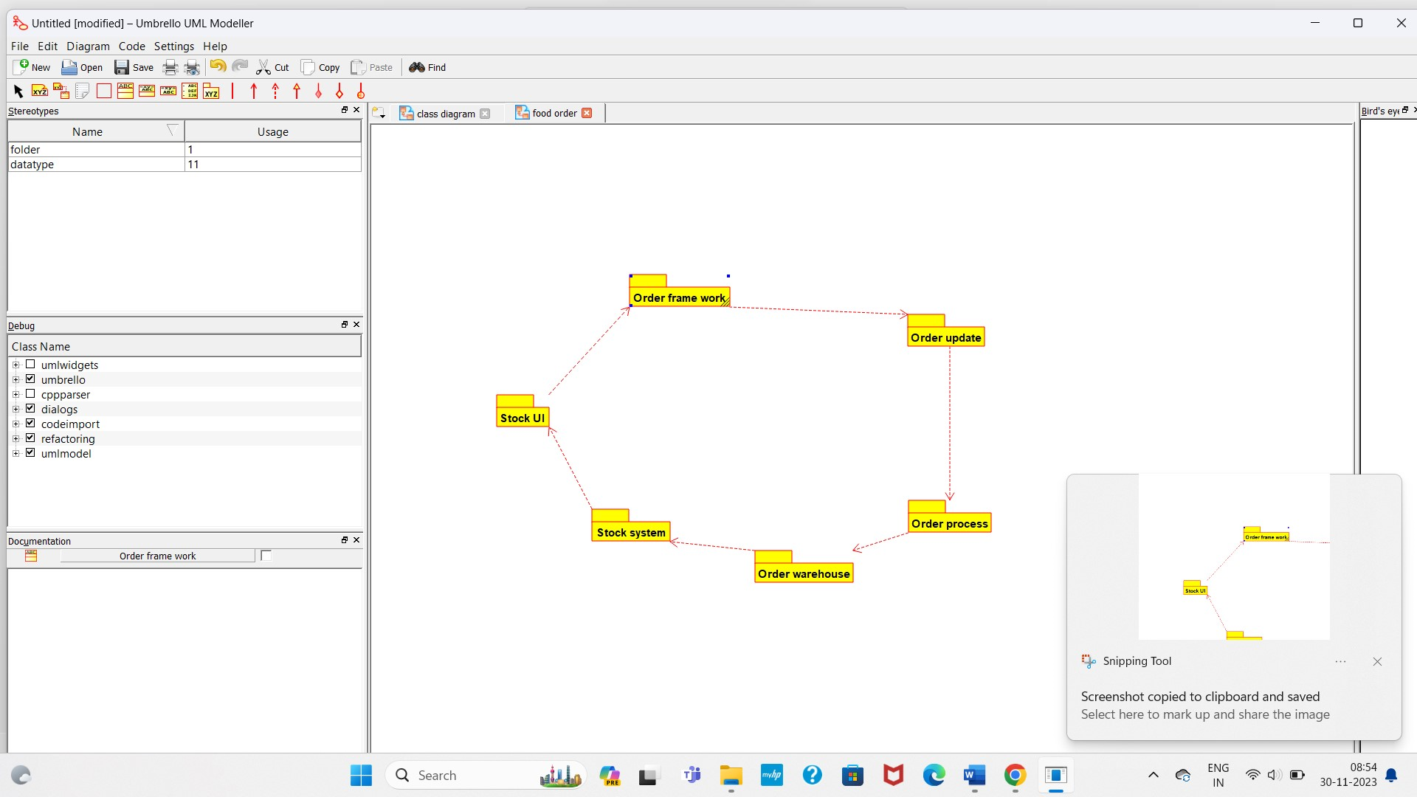

iagram: deployment diagram Page 1